Snapdragon Chemistry’s LabOS™ software allows researchers to collect data and control a wide range of scientific instruments through a single unified interface. LabOS™ grew out of a need for a simple system to control the wide range of equipment and sensors that are used in modern data-rich experimentation workflows. The architecture of the system is outlined below:
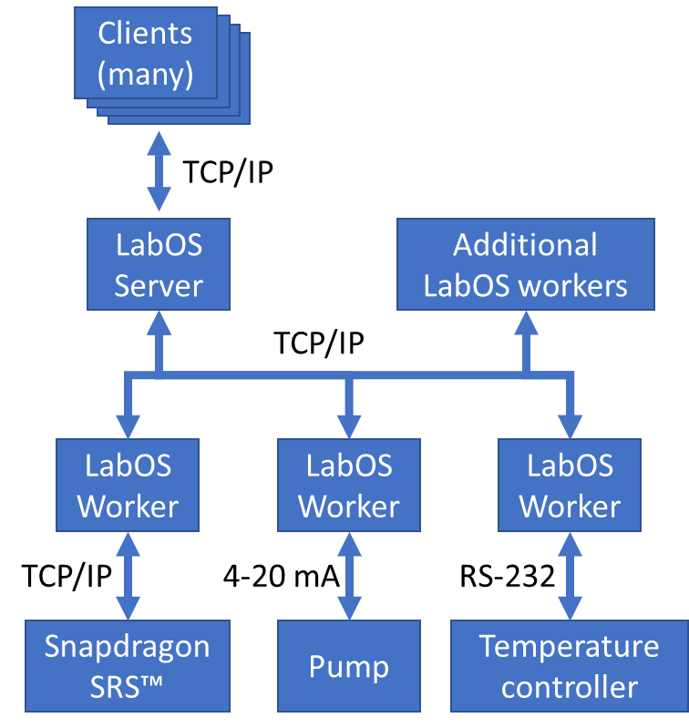
Specifications
Client interface | Brower-based. Multi-platform, desktop and mobile.
LabOS Server | Typically 16 GB RAM with SSD running Ubuntu Linux
LabOS Worker | Runs on Windows 10 or embedded devices
Example devices integrated with LabOS worker software | Flow meters, pumps, temperature controllers, fraction collectors, online LC (Snapdragon Sample Relay System™), DC Power supplies (electrochemistry, photochemistry)
Worker communication protocols | HTTP, Modbus TCP, Modbus RTU, RS-232, RS-485, 0-10 VDC, 0-20 mA, and others.  Integration with Windows API/SDK using .NET. Others possible on request.
Safety features | Alert SMS message if values out of expected range. Automated reactor shutdown to safe state.
Automation features | Software allows users to queue up a series of conditions to evaluate. For each condition, an automation routine will execute.  Integration with automation controllers for additional capability.
Self-optimizing reactor | Integration with the SNOBFIT optimization algorithm is available

Example screenshot
